**DIP Project 6**

**電信碩 沈衍薰 309513047**

1. **Source code**

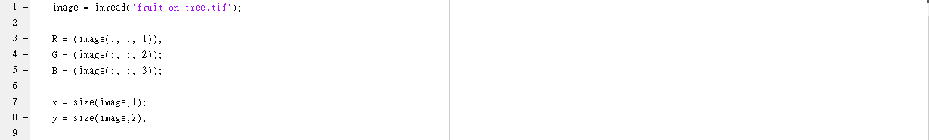

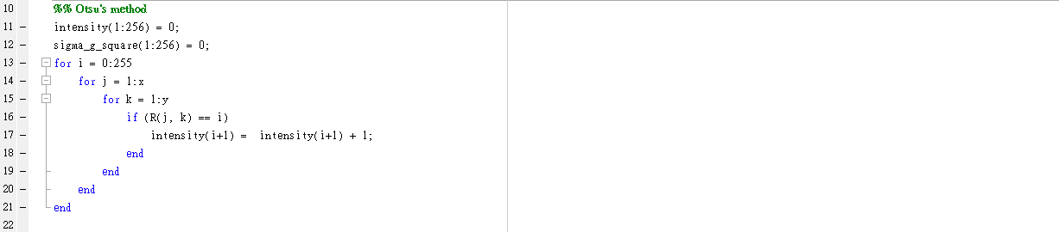

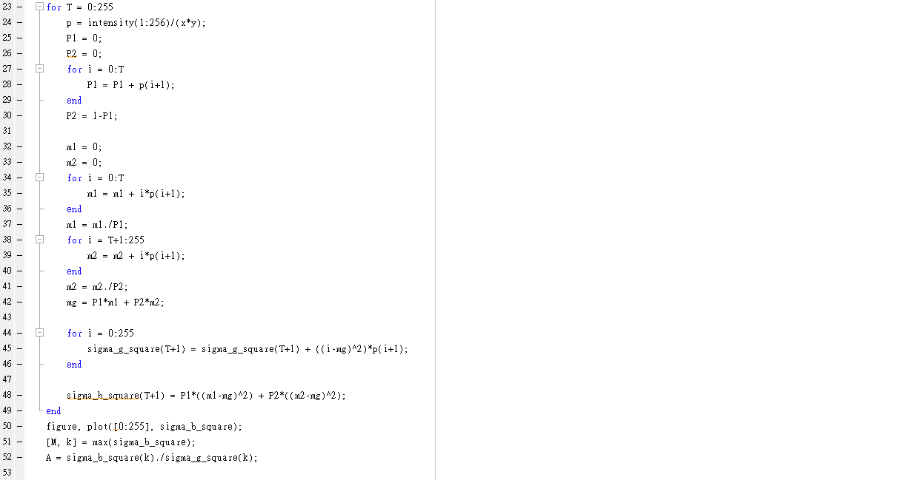

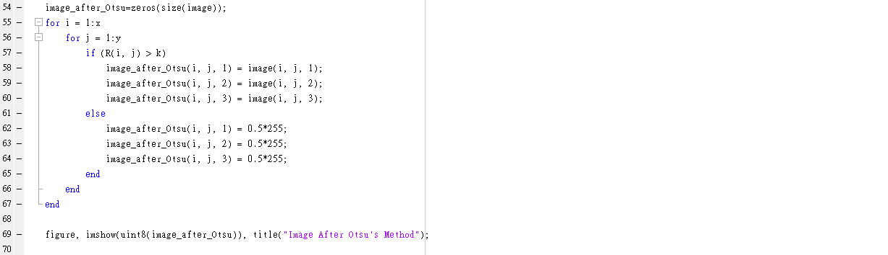

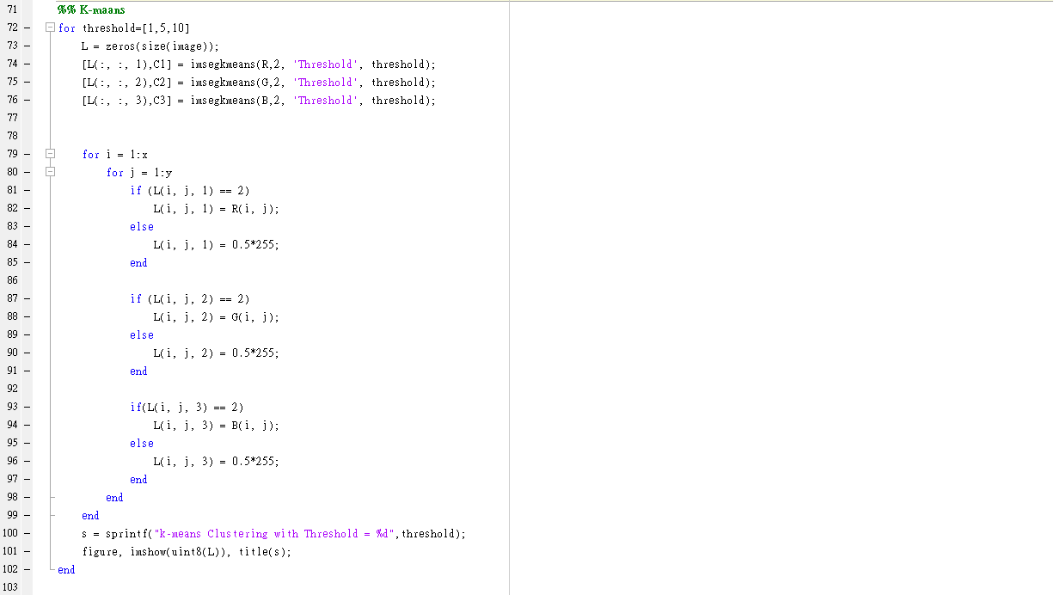

1. **Plot of the curve of between-class variance depending on all possible threshold values**

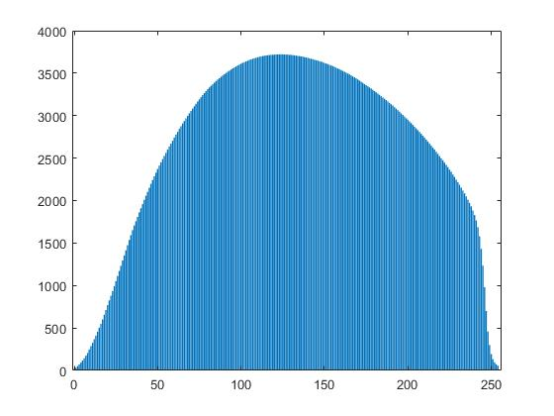

1. **Image of patterns extracted by Otsu’s algorithm**

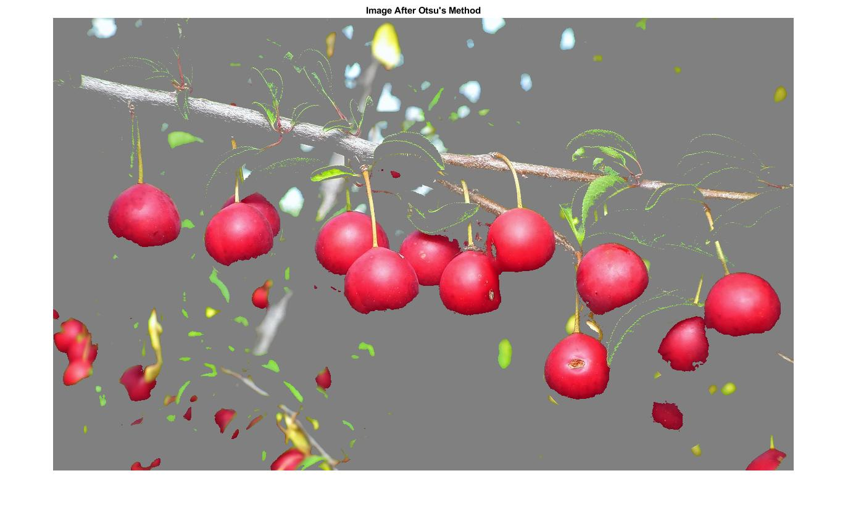

1. **Images of patterns extracted by K-means clustering with different threshold values**

